Chairman: Dr P Fielding FRCGP
Lay Secretary: Mr M J D Forster

To whom it may concern | 22nd March 2107

SCHOOLCHILDREN WITH LOOSE BOWELS
If one of your pupils has a loose bowel movement you may be wondering whether to send the child home.
Gloucestershire Public Health advice is that the official World Health Organisation’s definition of diarrhoea is 3 loose bowels in 24hrs. However, schools can send children home if a child passes a watery motion on just one occasion, but the key point is that it must be out of the ordinary for that child. Therefore, if the child is suffering from a known anxiety, Irritable Bowel Syndrome (IBS) or Inflammatory Bowel Disease (IBD) these motions are not considered out of the ordinary for that child. You should ask your pupil’s parents to confirm what the child’s ‘normal’ bowel state is.
While you may consider that a definitive letter from the child’s GP may help you make your decision you need to know that writing the letter is not part of the GP’s NHS contract and therefore the GP would be entitled to charge for his or her time, as would any professional. You should agree with the practice in advance that you will be prepared to pay that fee.
Yours sincerely
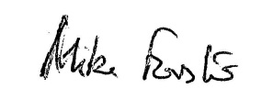

Mike Forster

LMC Lay Secretary

